Long-term nitrogen leaching
Dr. Kevin Frank

1. MTF funding is used for sampling costs and technical salary.

2. Grad students involved: none.

3. Research benefits turf managers understanding of fertilizer environmental fate and efficiency.

4. Project duration: indefinite, July 2026 will mark 28 years of consecutive data collection, this is the longest running turfgrass leaching research in the world and we will continue to apply treatments and collect samples with no end date scheduled.

5. Project Update

Since the summer of 1998 leachate samples have been collected from the monolith lysimeters at the HTRC and analyzed for nitrate-nitrogen. July 2025 marked 27 years of consecutive leachate collection and 35 years since turfgrass was established on the lysimeters. The high N rate of 5 lb. N/1000 ft.²/yr was applied in 1998 and concluded following the 2002 season. High levels of NO₃-N leaching were measured from the high N rate from 1998-2002. In 2003 the high N rate was reduced from 5 to 4 N/1000 ft.²/yr, and subsequently leachate NO₃-N concentrations declined over an approximately 15-year period. After 15 years of treating the high N rate at 4 lb. N/1000 ft.²/yr, in 2018 we reverted to applying urea at 5 lb. N/1000 ft.²/yr split over 5 applications to two of the lysimeters to determine if the high N rate would once again result in high nitrate-nitrogen concentrations in leachate. The application dates were May 1, June 1, July 1, Aug. 1, and Sept. 1. The remaining two lysimeters were treated with urea at 2 lb. N/1000 ft.²/yr split over two applications on May 1 and Sept. 1. The turf was mowed at 3 in. and clippings returned to the plots. Lysimeter percolate was collected regularly, volume measured, and a sub sample collected for NO₃-N.
Leachate was collected from January through December in 2025. The mean NO₃-N concentration in leachate for the low and high N rates was 1.2 and 6.0 ppm, respectively. After 8 years of the 5 lb. N rate, NO₃-N concentration in leachate has increased from 1 ppm in 2018 to 6.0 ppm in 2025.
This research will continue to measure nitrogen leaching in a continually managed turfgrass system and provide insight into the effect of fertilizer rates on nitrogen leaching from mature turfgrass stands.

Key Points

- After eight years of the high N rate, 5 lb. N/1000 ft.²/yr, mean annual nitrate-nitrogen concentrations have increased from 1 ppm in 2018 to 6.0 ppm in 2025.
- Dormant season leaching continues to be a point of concern for the high N rate application.

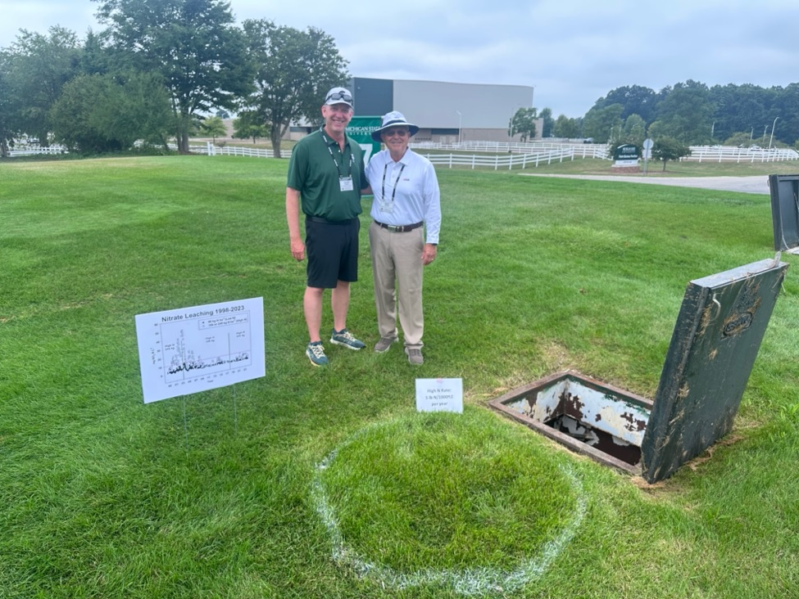

Photo: Dr. Mike Kenna, past director of the USGA Green Section Research and Dr. Kevin Frank at the long-term nitrogen leaching lysimeters at MSU.

